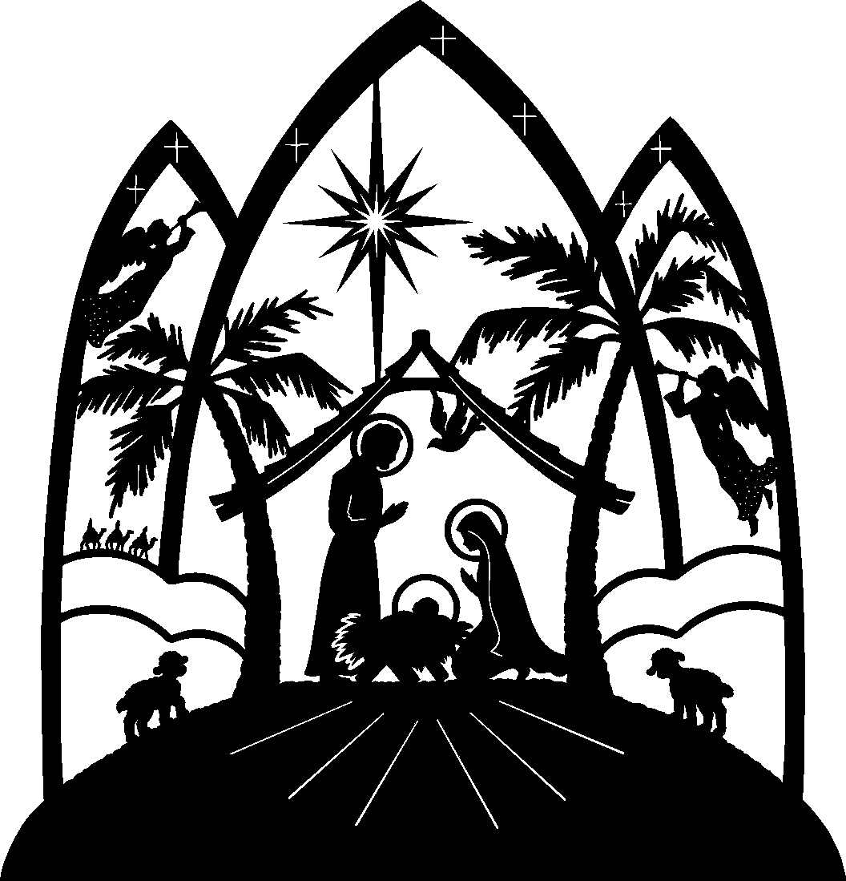

Christmas Eve

December 24, 2024

Bethany Lutheran

Laurens, Iowa

PRELUDE Shirley McKiernan

Welcome and Announcements

Lighting the Christ Candle

**CALL TO WORSHIP**: Oh, Come, All ye Faithful LBW # 45 (v1-3)

**CONFESSION AND FORGIVENESS**

P. Blessed be the holy Trinity, Father, Son and Holy Spirit, one God, who forgives all our sins, whose mercy endures forever.

**C. Amen.**

P. Amidst the darkness of this world, let us confess our sin and welcome the light of God’s forgiveness.

*(Silence is kept for reflection.)*

P. Mary accepted your call to be the mother of Jesus.

**C. Forgive our lack of faith and trust in your will.**

P. Your Son was born in the poverty of a stable.

**C. Forgive our neglect of the poor.**

P. The shepherds left their flocks and went to Bethlehem.

**C. Forgive our selfishness and complacency.**

P. The magi followed the star to find the Savior of the nations.

**C. Forgive our reluctance to seek you with all our hearts.**

P. The angel said, you shall call his name Jesus for he will save his people from their sins. With great joy, I announce to you the entire forgiveness of your sins, in the name of the Father, and of the Son, and of the Holy Spirit.

**C. Amen.**

**THE GREETING**

P. Alleluia! Christ is born for us.

**C. Oh, come, let us adore him.**

P. The grace of our Lord Jesus Christ, the love of God, and the communion of the Holy Spirit be with you always.

1

**C. And also with you.**

**HYMN OF PRAISE:** *Angels We Have Heard on High LBW#71*

**THE PRAYER OF THE DAY** (in unison)

P. The Lord be with you.

**C. And also with you.**

Let us pray…... **Almighty God, you made this holy night shine with the brightness of the true Light. Grant that here on earth we may walk in the light of Jesus’ presence and on that last day wake to the brightness of his glory; through your only Son, Jesus Christ our Lord, who lives and reigns with you and the Holy Spirit, one God, now and forever. Amen.** 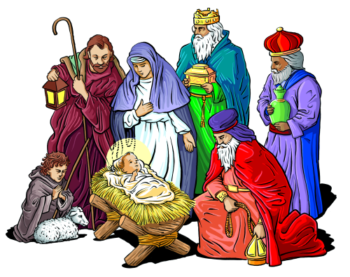

**FIRST LESSON**: Isaiah 9:2-7

2 The people who walked in darkness have seen a great light;  
those who lived in a land of deep darkness— on them light has shined.

2

3 You have multiplied the nation,   you have increased its joy;  
they rejoice before you as with joy at the harvest,   as people exult when dividing plunder

.4 For the yoke of their burden, and the bar across their shoulders, the rod of their oppressor, you have broken as on the day of Midian.5For all the boots of the tramping warriors  
 and all the garments rolled in blood shall be burned as fuel for the fire.6 For a child has been born for us, a son given to us; authority rests upon his shoulders; and he is named wonderful Counsellor, Mighty God, Everlasting Father, Prince of Peace.7 His authority shall grow continually, and there shall be endless peace for the throne of David and his kingdom. He will establish and uphold it with justice and with righteousness from this time onwards and for evermore. The zeal of the Lord of hosts will do this.

***PSALM: Psalm 96***  *(read responsively)*

1O sing to the Lord a new song; sing to the Lord, all the earth.

**2Sing to the Lord, bless his name; tell of his salvation from day to day.**

3Declare his glory among the nations, his marvelous works among all the peoples.

**4For great is the Lord, and greatly to be praised; he is to be revered above all gods.**

3

5For all the gods of the peoples are idols, but the Lord made the heavens. Honor and majesty are before him; strength and beauty are in his sanctuary.

**8Ascribe to the Lord the glory due his name; bring an offering, and come into his courts.**

9Worship the Lord in holy splendor; tremble before him, all the earth.

**10Say among the nations, “The Lord is king! The world is firmly established; it shall never be moved. He will judge the peoples with equity.”**

11Let the heavens be glad, and let the earth rejoice; let the sea roar, and all that fills it;

**12let the field exult, and everything in it. Then shall all the trees of the forest sing for joy**

13before the Lord; for he is coming, for he is coming to judge the earth. He will judge the world with righteousness, and the peoples with his truth.

**SECOND LESSON**: Titus 2:11-14

11 For the grace of God has appeared, bringing salvation to all, 12training us to renounce impiety and worldly passions, and in the present age to live lives that are self-controlled, upright, and godly, 13while we wait for the blessed hope and the manifestation of the glory of our great God and Saviour, Jesus Christ. 14He it is who gave himself for us that he might redeem us from all iniquity and purify for himself a people of his own who are zealous for good deeds.

**GOSPEL PROCESSIONAL**: ***O Little Town of Bethlehem***  *LBW 41 (v1-2))*

**HOLY GOSPEL**: Luke 2:1-20

4

***C. Glory to you, O Lord***

1In those days a decree went out from Emperor Augustus that all the world should be registered. 2This was the first registration and was taken while Quirinius was governor of Syria. 3All went to their own towns to be registered. 4Joseph also went from the town of Nazareth in Galilee to Judea, to the city of David called Bethlehem, because he was descended from the house and family of David. 5He went to be registered with Mary, to whom he was engaged and who was expecting a child. 6While they were there, the time came for her to deliver her child. 7And she gave birth to her firstborn son and wrapped him in bands of cloth, and laid him in a manger, because there was no place for them in the inn.8 In that region there were shepherds living in the fields, keeping watch over their flock by night. 9Then an angel of the Lord stood before them, and the glory of the Lord shone around them, and they were terrified. 10But the angel said to them, ‘Do not be afraid; for see—I am bringing you good news of great joy for all the people: 11to you is born this day in the city of David a Saviour, who is The Messiah, the Lord. 12This will be a sign for you: you will find a child wrapped in bands of cloth and lying in a manger.’ 13And suddenly there was with the angel a multitude of the heavenly host, praising God and saying,14 ‘Glory to God in the highest heaven,   and on earth peace among those whom he favours!’15 When the angels had left them and gone into heaven, the shepherds said to one another, ‘Let us go now to Bethlehem and see this thing that has taken place, which the Lord has made known to us.’ 16So they went with haste and found Mary and Joseph, and the child lying in the manger. 17When they saw this, they made known what had been told them about this child; 18and all who heard it were amazed at what the shepherds told them. 19But Mary treasured all these words and pondered them in her heart. 20The shepherds returned, glorifying, and praising God for all they had heard and seen, as it had been told them.

**C. Praise to you O Christ**

**5**

**GOSPEL HYMN:**  ***O Little Town of Bethlehem*** *LBW 41(v3-4)*

**CHILDREN’S SERMON Pastor David Klappenbach**

**CHILDREN’S HYMN**: *Away in a Manger LBW 67*

**SERMON: Pastor David Klappenbach**

**HYMN**: Go Tell It on the Mountain LBW#70

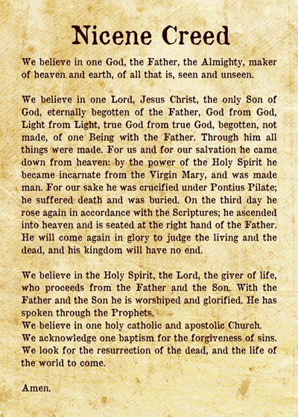

6

**THE PRAYERS**

**P.** Rejoicing that we have seen the salvation of our God in the birth of Jesus the Messiah, let us pray for the church, the world, and all people in need.

**A.** God of glory, purify your church and transform its members into your own people, zealous to make known the truth of salvation in Jesus Christ to all the world. Draw near to us, O God,

**and receive our prayer.**

**A.** God of glory, curb the desire to fill the emptiness in our lives with material things, and open our eyes to see the goodness of creation revealed in your Word made flesh. Draw near to us, O God,

**and receive our prayer.**

**A.** God of glory, break the yokes of war and oppression that plague our world, establish your peace among nations, and uphold it with justice and righteousness for all peoples. Draw near to us, O God,

**and receive our prayer.**

**A.** God of glory, shine the light of your grace on all who are homeless, fearful, sick, or hospitalized. Cast out their fear and restore them to wholeness according to your promise. Draw near to us, O God,

**and receive our prayer.**

**A.** God of glory, turn the hearts of those gathered here to the strangers among us and teach us to welcome them as the very Christ who comes to dwell with us. Draw near to us, O God,

**and receive our prayer.**

A. God of glory, we wait with hope for your glory yet to be revealed and for that day when we are united with all the saints who rest in you. Draw near to us, O God,

**and receive our prayer.**

7

**P.** Hear these prayers, O God, offered in the name of your Son, who has made your glory and graciousness known to us.

**Amen.**

**THE OFFERING**

**OFFERING RESPONSE**: *What Child Is This LBW #40 (v1 & 3)*

**THE OFFERING PRAYER**

**C. Eternal God, with Mary we treasure the gift of your Son, and in our hearts we ponder the mystery of his birth. Receive these offerings, that our lives may declare the wonders of your love in Jesus Christ our Lord. Amen.**

**THE GREAT THANKSGIVING**

P. The Lord be with you.

**C. And also with you.**

P. Lift up your hearts.

**C. We lift them to the Lord.**

P. Let us give thanks to the Lord our God.

**C. It is right to give our thanks and praise.**

P. It is indeed right and salutary………we praise your name and join their unending hymn : P.68

C Holy, holy, holy………. P.69

**THE THANKSGIVING PRAYER**

P. Holy God, Creator of all and Source of life, at the birth of time your Word brought light into the world. In the fullness of time, you sent your Word, born of Mary, to shine in our darkness and

8

In the night in which he was betrayed, our Lord Jesus took bread, and gave thanks; broke it, and gave it to his disciples, saying: Take and eat; this is my body, given for you. Do this for the remembrance of me.

Again, after supper, he took the cup, gave thanks, and gave it for all to drink, saying: This cup is the new covenant in my blood, shed for you and for all people for the forgiveness of sin. Do this for the remembrance of me.

Remembering, therefore, his birth and life among us, his death and resurrection, we await his coming again when all things will be restored in him. By your Spirit bless us and this bread and cup, that, held and nourished by you, we may live as your children, shining with the light of your Son. Through him all glory and honor is yours, Almighty Father, with the Holy Spirit, in your holy Church, both now and forever.

**C. Amen**

**THE LORD’S PRAYER**

**THE DISTRIBUTION OF THE MEAL**

*(The Sharing of the Meal — All who are baptized and believe are invited to join and receive the gift of God’s grace. HOLY COMMUNION shall be continuous at the front of the sanctuary at floor level. After receiving the bread, please move to the communion assistant on your side of the church returning to your seat after receiving the elements. For grape juice, take a cup from the center of the tray.)*

9

**THE POST COMMUNION PRAYER**

P. God of light, with our eyes we have seen your salvation, and, in this supper, we have feasted on your grace. Send us forth into the world to be your holy people, revealing your glory made known to us in Jesus Christ our Lord.

**C. AMEN**

**Lighting of the Candles**

A. The Word was made flesh, and we beheld his glory.

**C. Oh, come, let us worship him.**

A. The people who walked in darkness have seen a great light.

**C. The light shines in the darkness and the darkness has not overcome it.**

A. Those who dwelt in the land of deep darkness, on them has light shined.

**C. We have beheld Christ’s glory, glory as of the only Son of the Father.**

A. For to us a child is born, to us a Son is given.

**C. In him was life, and the life was the light of** **all.**

**HYMN OF LIGHT**: *Silent Night, Holy Night LBW #65*

**THE BENEDICTION**

P. May Christ, born into time to bring endless peace, guide your days and years in righteousness from this time onward and forevermore. The Lord bless you and keep you, The Lord shine on you with His grace and mercy. The Lord give you His favor and peace.

**C. Amen.**

**10**

**THE SENDING**

P. Filled with the joy of Christ’s birth, go in peace to love and serve the Lord.

**THE SENDING HYMN**: Joy to the World LBW #39

**C. Thanks be to God.**

Poinsettias

Two Poinsettias on the Altar are a Thank You to God for Blessing us with 65 years of marriage. Myles & Shirley Pedersen

In Loving Memory of Eldred & Margaret Hedstrom. Ray & Cheryl Painter

In Memory of those who have gone before us. Kelly, Dawn and Michelle

In Loving Memory of Ron Hersom. From his family

Assisting Ministers:

Lector: Pat Boughey

Acolytes: Raelyn Johnsen

Ushers: Dean Armstrong

Eloise Armstrong

11